Entertainment
Hempstead

28th annual LI International Film Expo kicks off in Bellmore
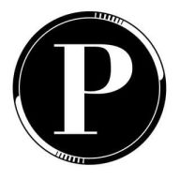By Long Island Press
Posted on July 10, 2025
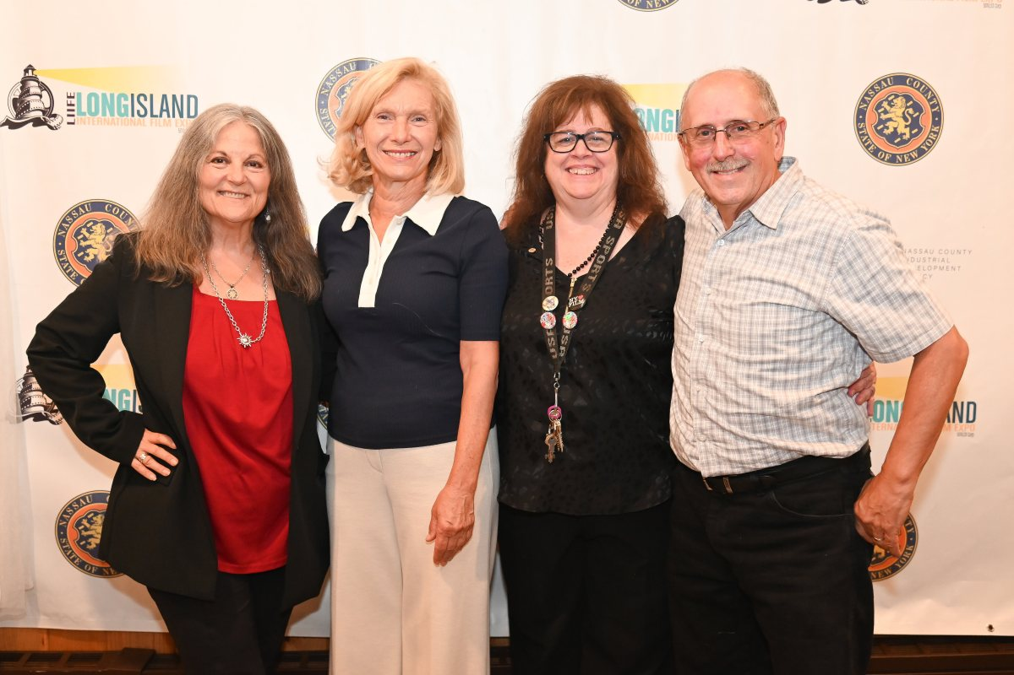
Co-founder of the LI International Film Expo, Debra Markowitz, Nassau County Comptroller Elaine Phillips, and cofounders of the LI International Film Expo Anne Stampfel and Henry Stampfel
Ed Shin
The 28th Long Island International Film Expo (LIIFE) kicked off on July 9 at the historic Bellmore Movies and Showplace in Bellmore.
With a dynamic lineup featuring over 130 short and feature-length entries from local, national, and international filmmakers, the LI International Film Expo stays true to its mission of showcasing bold, diverse voices.
Alongside screenings in genres spanning drama, comedy, horror, sci-fi, documentary, animation, LGBTQIA+, and family films, attendees can expect edgy late-night madness lineups — elements that previously earned the fest praise as “a must-attend” for genre lovers.
Recent attendee reviews from 2024 highlight this mix of professionalism and intimacy, noting the well-organized structure, welcoming atmosphere, and handcrafted trophies for standout horror entries.
In addition to screenings, the expo delivers robust industry engagement including filmmaker panels, a breakfast networking event, and an Assistant Director Expo featuring hands-on sessions with an Assistant Director. These gatherings, held daily in the Filmmakers Lounge, create fertile ground for networking and creative collaboration.
The LI International Film Expo is also known for its red-carpet occasions, celebrity guests, and vibrant awards ceremony, ensuring a professional yet intimate community experience. Whether you’re a filmmaker, industry professional, or local film enthusiast in NYC, LIIFE offers an engaging, inclusive, and culturally rich week celebrating independent storytelling on and off the screen.
The LI International Film Expo will run from July 9 to 13. For more information on films, panels and tickets, visit longislandfilm.com.

